# Journaling user activities and predictive different mood states -using NLP

In this part we take the famous tweet emotion dataset- [data](https://www.kaggle.com/datasets/pashupatigupta/emotion-detection-from-text) and predict emotions based on the tweets made by the user. This dataset consists of around 40k tweets spanning across 13 emotions namely neutral, worry, happiness, sadness, love, surprise, fun, relief, hate, empty, enthusiasm, boredom, anger.

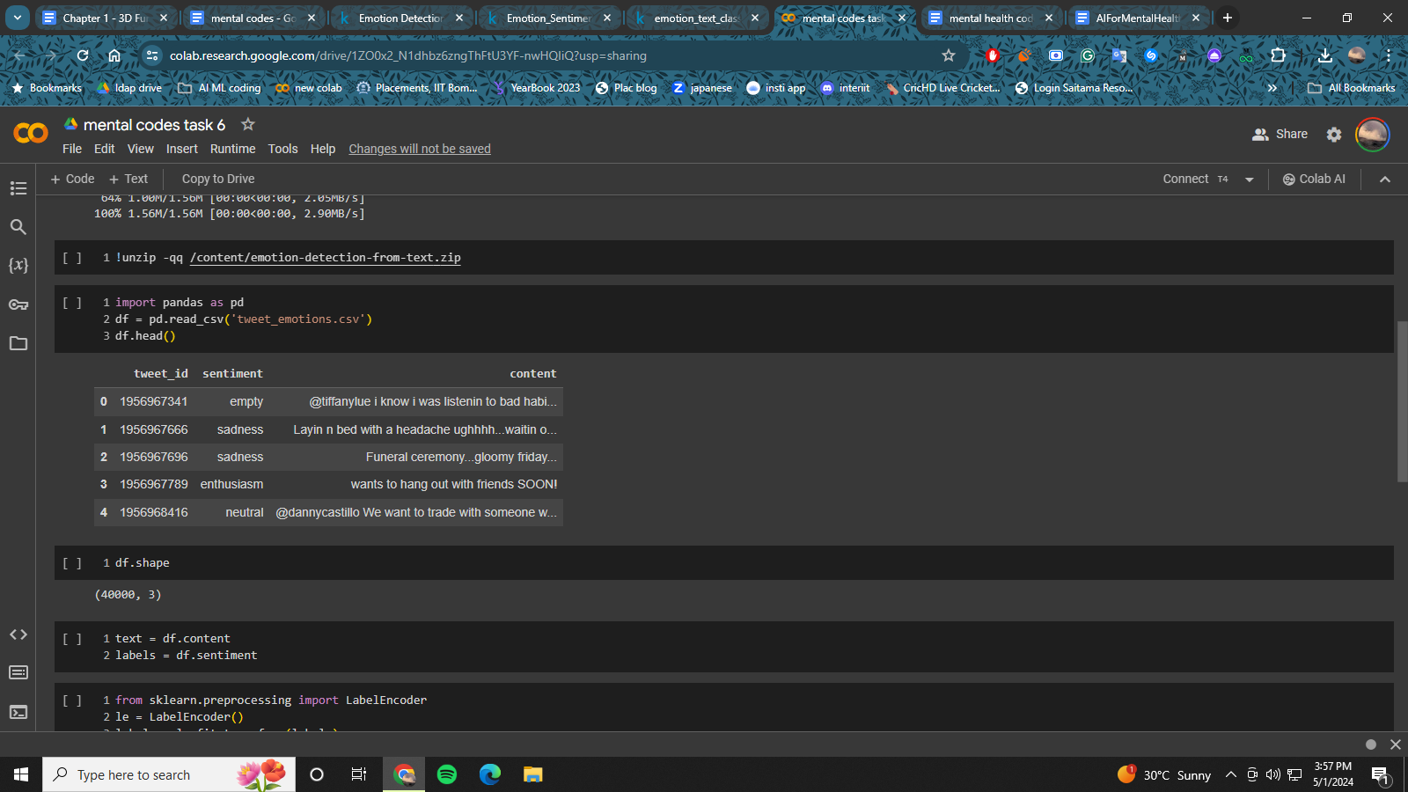

First we begin by loading the dataset using the pandas library. After this we use the labelencoder to convert the string labels into integer classes so that it can be fed into the models for training. We treat this as a text classification problem and use the famous Roberta model which is a transformer based model widely used for this purpose. We also make use of the KerasNLP library which makes it easy for us to use large NLP models along with pretrained weights so that we can easily finetune and use them.

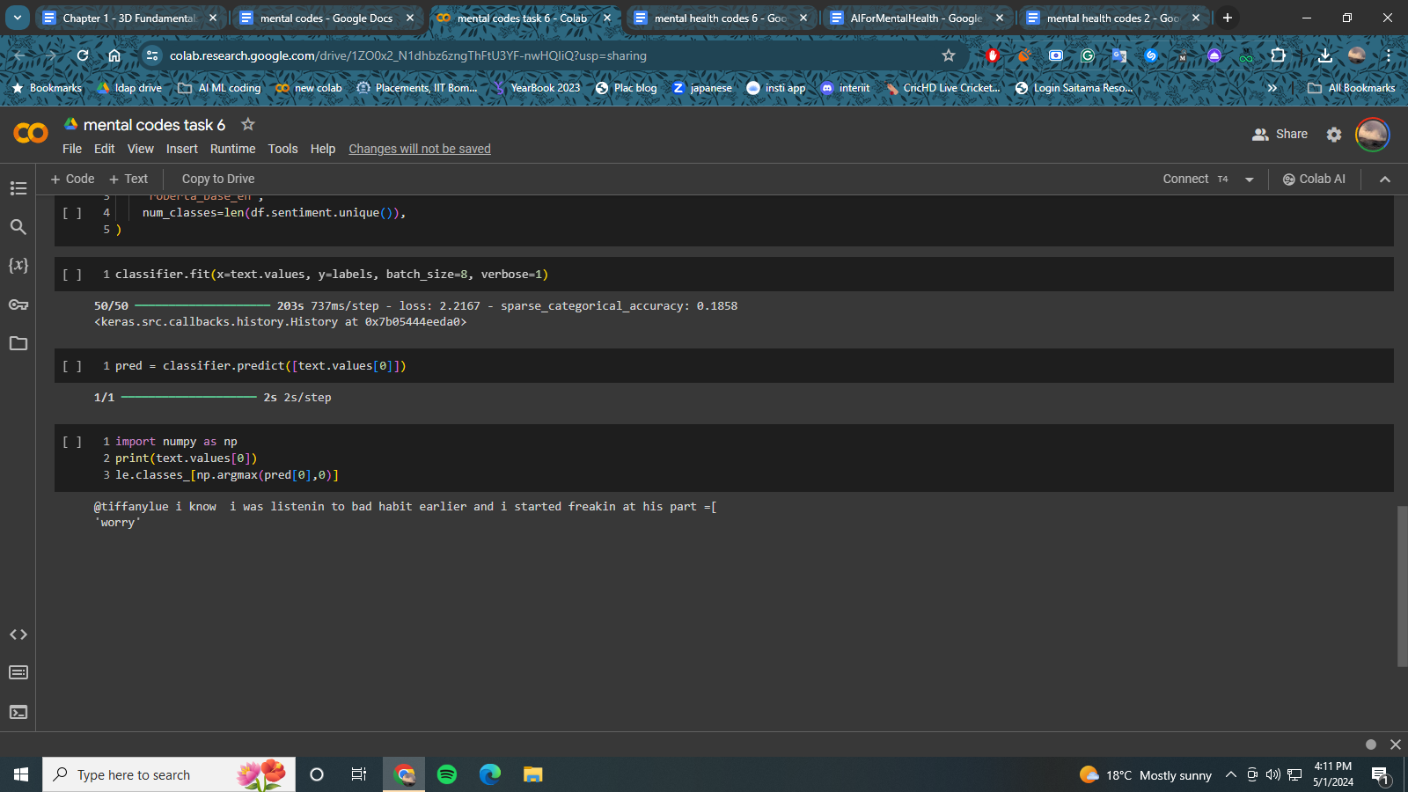

## CODE:

## Installation

Pip install pandas sklearn keras-nlp

## Imports

Import pandas as pd

from sklearn.preprocessing import LabelEncoder

import keras_nlp

Import numpy as np

## Data Loading

df = pd.read_csv('train.csv')

## Data processing

text = df.content

labels = df.sentiment

le = LabelEncoder()

labels = le.fit_transform(labels)

## Model Building

classifier = keras_nlp.models.RobertaClassifier.from_preset(

"roberta_base_en",

num_classes=len(df.sentiment.unique()),

)

classifier.fit(x=text.values, y=labels, batch_size=8, verbose=1)

## Model Prediction

pred = classifier.predict([text.values[0]])

print(text.values[0])

le.classes_[np.argmax(pred[0],0)]